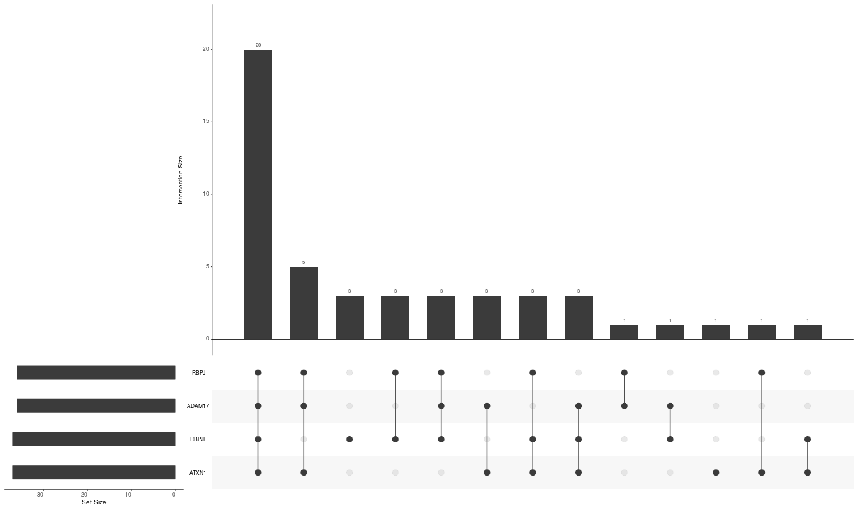

Figure 1. The UpSet analysis of the Notch core profiles associated with DFS for early stage PC in patients below 55 years old revealed the signature involving *RBPJ, ADAM17, RBPJL,* and *ATXN1*. The favorable profile of the signature was identified among 20 (37.7%) out of 53 patients.

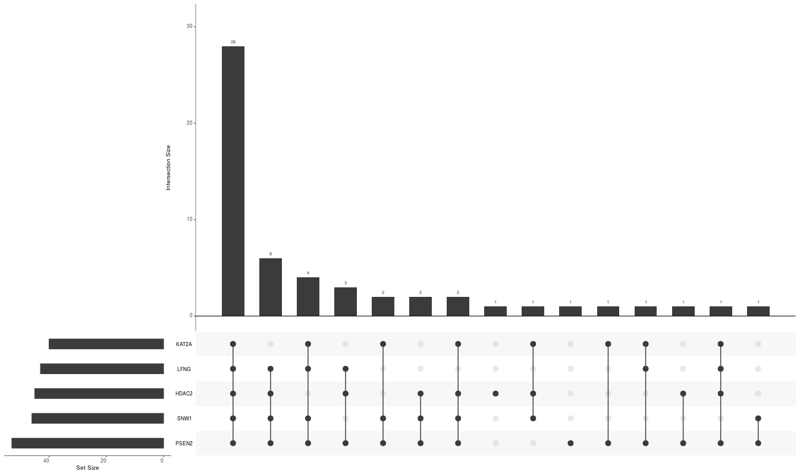

Figure 2. The UpSet analysis of the Notch core profiles associated with DFS for late stage PC in patients below 55 years old revealed the signature involving *KAT2A, LFNG, HDAC2, SNW1,* and *PSEN2*. The favorable profile of the signature was identified among 28 (50%) out of 57 patients.

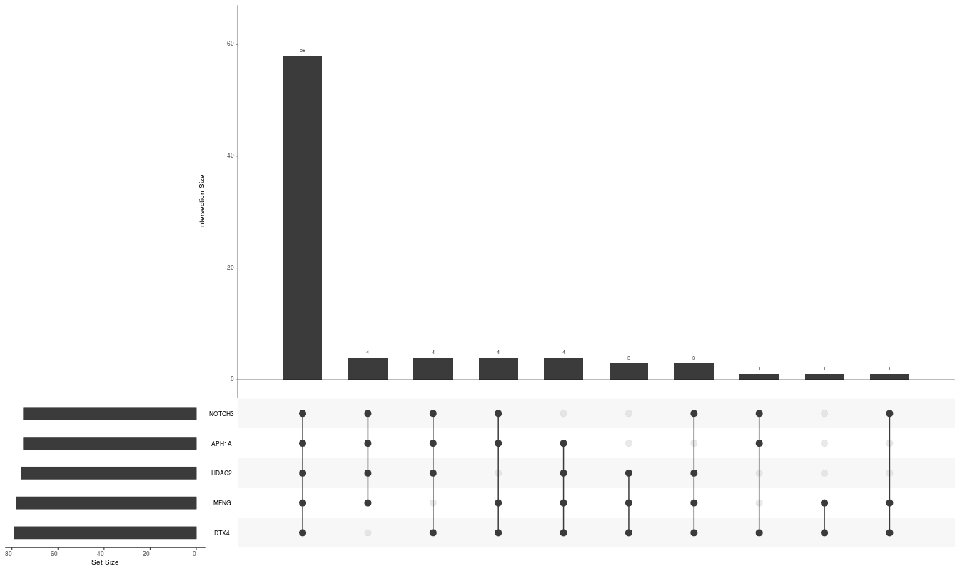

Figure 3. The UpSet analysis of the Notch core profiles associated with DFS for early stage PC in patients aged 60-70 years old revealed the signature involving *NOTCH3, APH1A, HDAC2, MFNG,* and *DTX4*. The favorable profile of the signature was identified among 58 (69%) out of 84 patients.

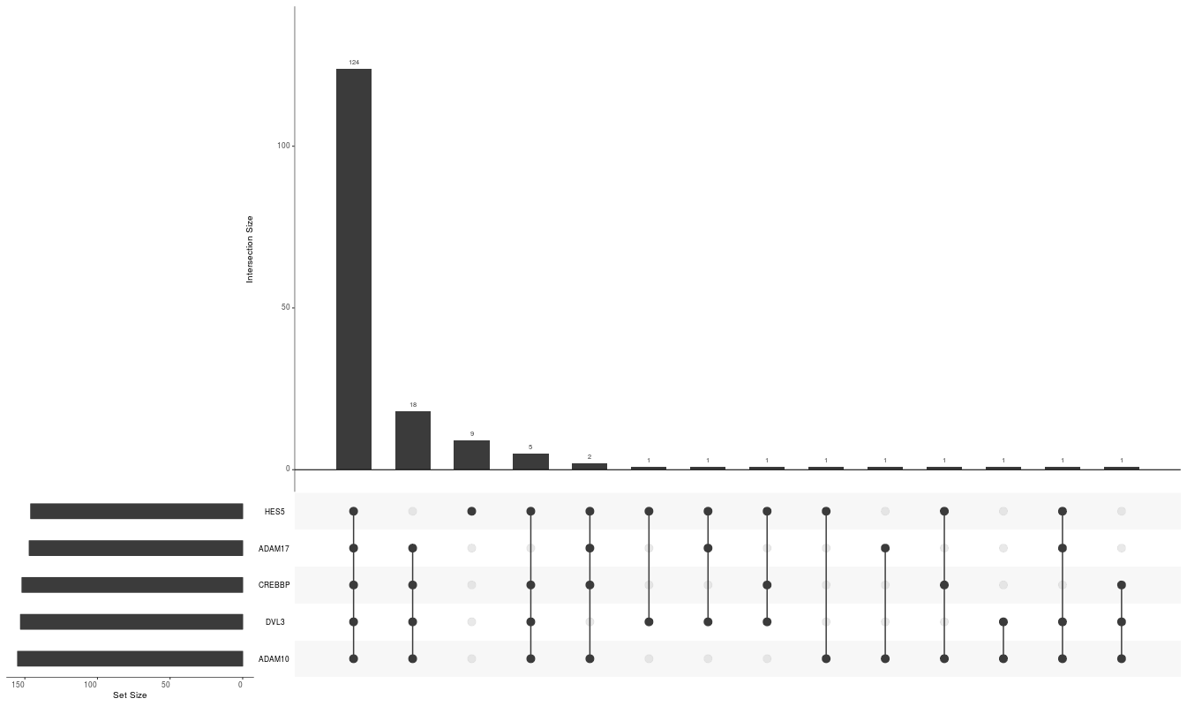

Figure 4. The UpSet analysis of the Notch core profiles associated with DFS for late stage PC in patients aged 60-70 years old revealed the signature involving *HES5, ADAM17, CREBBP, DVL3,* and ADAM10. The favorable profile of the signature was identified among 124 (73.4%) out of 169 patients.

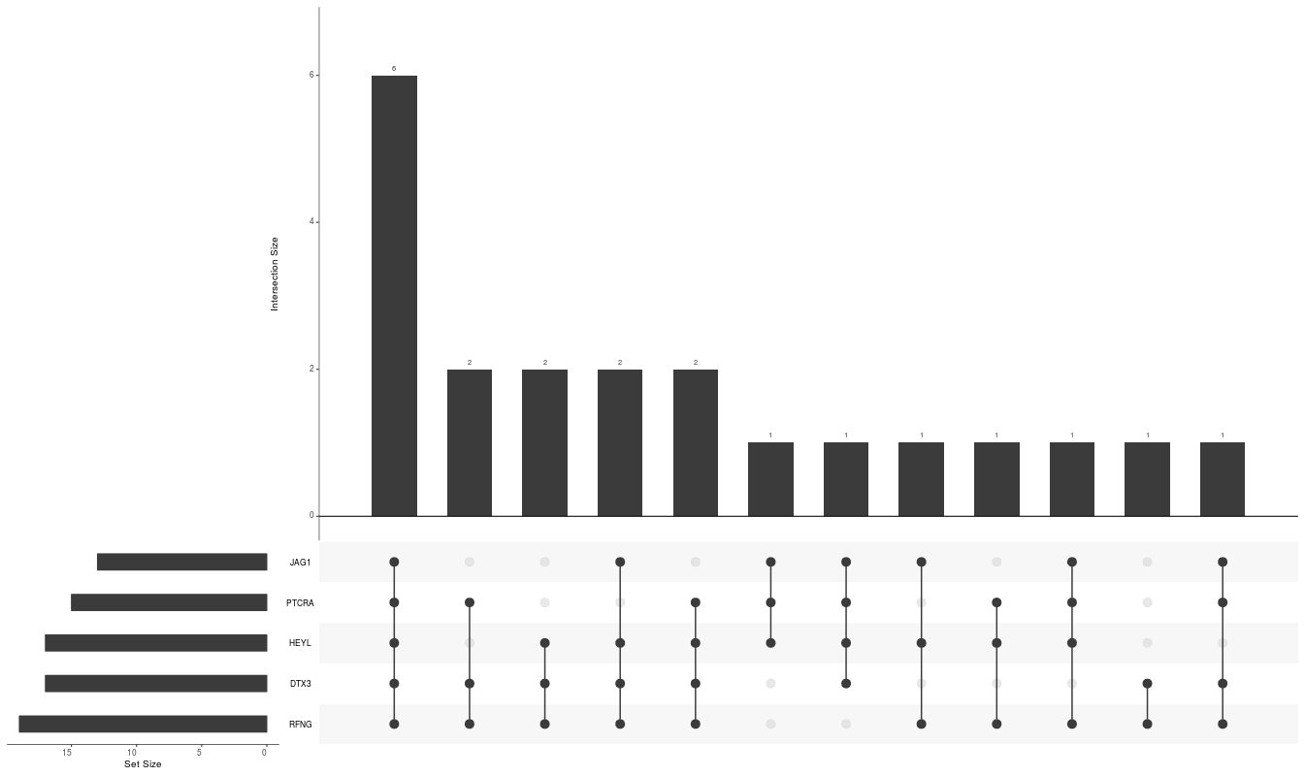

Figure 5. The UpSet analysis of the Notch core profiles associated with DFS for late stage PC in patients ABOVE 70 years old revealed the signature involving *JAG1, PTCRA, HEYL, DTX3,* and *RFNG*. The favorable profile of the signature was identified among 6 (27.3%) out of 22 patients.